**JWT AUTHENTICATION AND JWT AUTHORIZATION USING IDENTITY FRAMEWORK**

1.Create a simple WEB API project with controller.

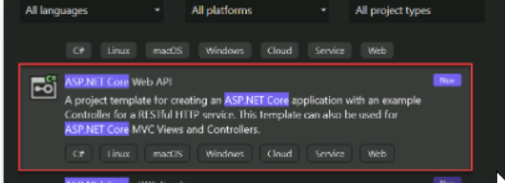

2.Install the necessary dependencies like SQLServer,JWTBearer,Tools,Identity framework.

3.Configure the appsettings by adding the connection string for SQLServer and JWTAuth with Secret key.

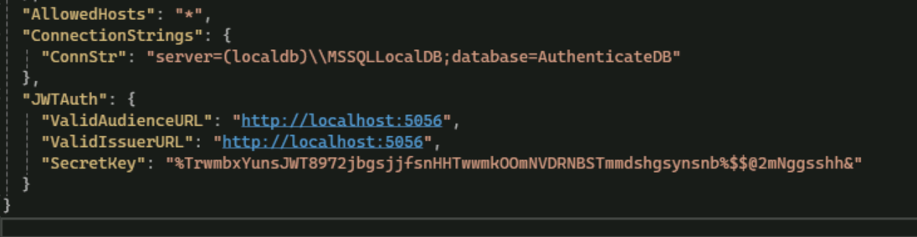

4.Create a folder named DatabaseContext and Create a AppDbContext for the database and implement IdentityDbContext which is from the Identity package.

5.In Program.cs add the DbContext service and do the migration and updating of the database and proceed only if the build is successful and all the tables are created.



6.Create a Models folder and add the necessary models like:

* Login - Username, Password
* Register - Username, Password, Email
* UserRoles - Fields like User, Admin etc.
* Response - Status, Message

7.Create a Controller folder and add AuthController and add endpoints like Login for user and admin, registering for user, Registering for admin and write JWT token creation method.

Login:

Register:

Register for admin:

Creating token:

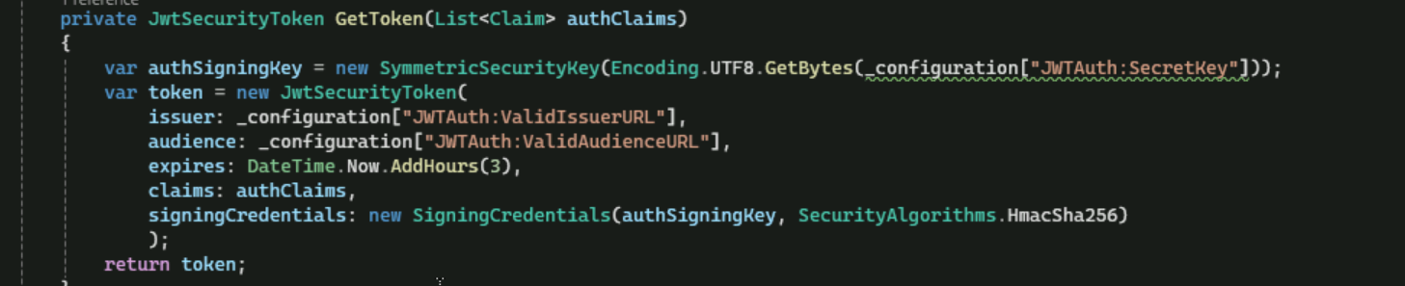

8. In program.cs do the following services:

* AddIdentity

* AddAuthentication

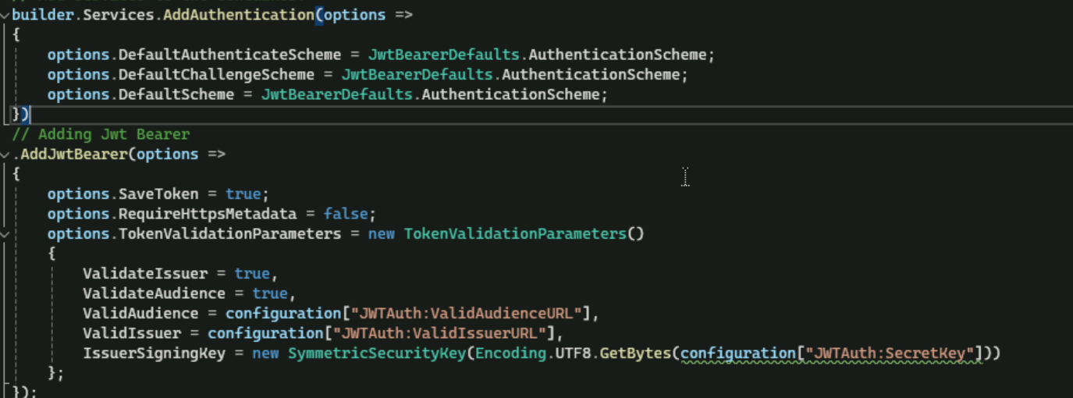

And add app.UseAuthentication() in the pipeline.

